**Unit II - Process Management**

**Process Concept :**

A process is a program in execution. A process is an 'active' entity as opposed to program which is considered to be a 'passive' entity. Attributes held by process include hardware state, memory, CPU etc. When a program is loaded into the memory and it becomes a process, it can be divided into four sections ─ stack, heap, text and data.

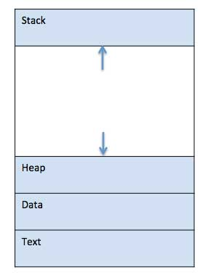

* **Stack** -The process Stack contains the temporary data such as method/function parameters, return address and local variables.
* **Heap** - This is dynamically allocated memory to a process during its run time.
* **Text** - This includes the current activity represented by the value of Program Counter and the contents of the processor's registers**.**
* **Data** - This section contains the global and static variables.

**Process Life Cycle:**

When a process executes, it passes through different states. In general, a process can have one of the following five states at a time.

* **New -** This is the initial state when a process is first started/created.
* **Ready -** The process is waiting to be assigned to a processor. Ready processes are waiting to have the processor allocated to them by the operating system so that they can run.
* **Running -** Once the process has been assigned to a processor by the OS scheduler, the process state is set to running and the processor executes its instructions.
* **Waiting -** Process moves into the waiting state if it needs to wait for a resource, such as waiting for user input, or waiting for a file to become available.
* **Terminated or Exit -** Once the process finishes its execution, or it is terminated by the operating system, it is moved to the terminated state where it waits to be removed from main memory.

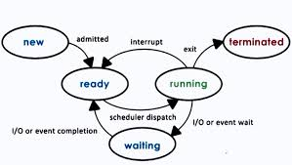

**Process Control Block (PCB):**

A Process Control Block is a data structure maintained by the Operating System for every process. The PCB is identified by an integer process ID (PID). The architecture of a PCB is completely dependent on Operating System and may contain different information in different operating systems.

* **Process State** - The current state of the process i.e., whether it is ready, running, waiting, or whatever.
* **Process privileges** - This is required to allow/disallow access to system resources.
* **Process ID** - Unique identification for each of the process in the operating system.
* **Pointer** - A pointer to parent process.
* **Program Counter** - Program Counter is a pointer to the address of the next instruction to be executed for this process.
* **CPU registers** - Various CPU registers where process need to be stored for execution for running state.
* **CPU Scheduling Information** - Process priority and other scheduling information which is required to schedule the process.
* **Memory management information** - This includes the information of page table, memory limits, Segment table depending on memory used by the operating system.
* **Accounting information** - This includes the amount of CPU used for process execution, time limits, execution ID etc.
* **IO status information** - This includes a list of I/O devices allocated to the process.

